April 2015 ATD Dallas Chapter Meeting - Culturetopia with Jason Young @ MaryKay

Jason Young has worked for Southwest Airlines, arguably, one of the most popular airline companies in the United States and he worked at one of the most revered airports in America - Los Angles International Airport - LAX. And despite the torture that Jason endured while working at LAX, he presented his notion of "Culturetopia" to the ATD Dallas Chapter at the April meeting with vigor, excitement, and tons of energy.

The idea of Culturetopia, a term Young confesses is completely made up, is creating high performance and high fulfillment in an organization by leveraging a strong culture. Learning and development is a critical piece to achieving culturetopia.

Jason shared a matrix on which all organizations fall.
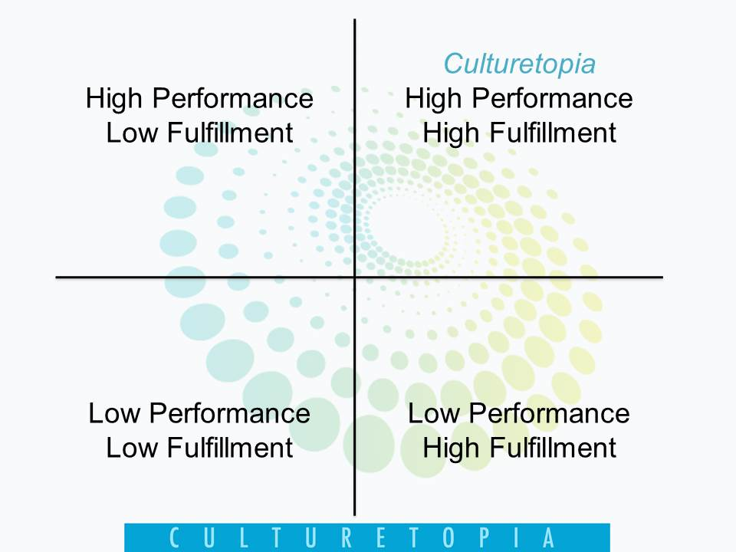 | - Top left quadrant: Employees are bitter/tired/frustrated/angry and if they stay long enough, their performance will drop.  - Bottom left quadrant: Employees that are depressed, not engaged, not involved.  - Bottom right quadrant: Likely a new hire employee where the goal of the organization is to make him/her a high performer very soon.  - Top right quadrant: Culturetopia, employees are eager, happy, engaged, and most of all, productive.
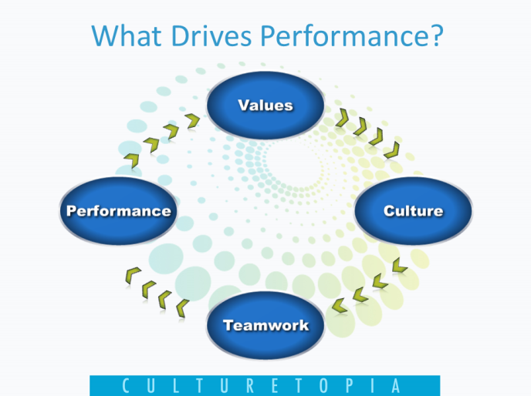

A common question of many organizations is "What drives performance?" Jason explained performance drivers in four steps:
- Performance
- Teamwork
- Culture
- Values
In the book, "The Southwest Airlines Way" Southwest Airlines conducted a study at Boston's Logan International Airport on "relational coordination." Dr. Gittell developed a theory of relational coordination, proposing that work is most effectively coordinated through relationships of shared goals, shared knowledge and mutual respect, and demonstrating how organizations can support relational coordination through the design of their work systems. Simply put, lower people tensions in order to increase performance.

During the early 1990s, many customer service training departments were cut at other airlines in the United States. Southwest increased funding and focused on spending time with the best performing employees in order to find out which behaviors needed to be reinforced around the company.

Jason gave attendees many nuggets of wisdom:
- Successful people are willing to do what others aren't. They don't necessarily know the most.
- Go back and spend time trying to find out what people are doing right.
- Tell family and customers "yes" instead of "no."
- Start being an enthusiastic and uplifting person because if you strongly believe in what you can do, others will believe it too.
Young also offered up some leadership best practices.
- Define expectations
- Provide tools and training to ensure success
- Use talents and strengths - "Soar with Your Strengths"
- Give frequent recognition and praise
- Show care and concern for everyone
- Encourage continuous learning and development
With accountability, Young believes that with full responsibility comes empowerment and influence, which leads to employees who feel as though they are able to make a decision and move forward. They feel more in control.

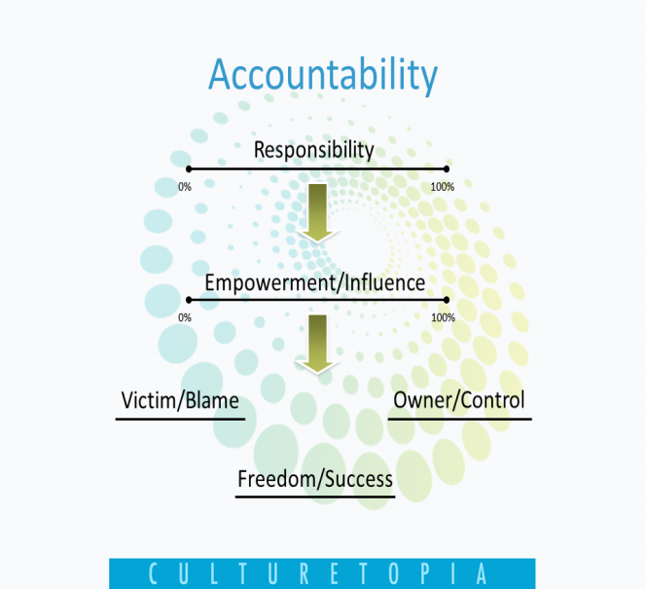

Being a team player is all about being part of something bigger than oneself. Team members must be able to trust and rely on each other, even in times when difficult conversations are needed. They need to leverage expertise through strengths and abilities, create an alignment and commitment that is agreed upon. Lastly, measurement through accountable members.

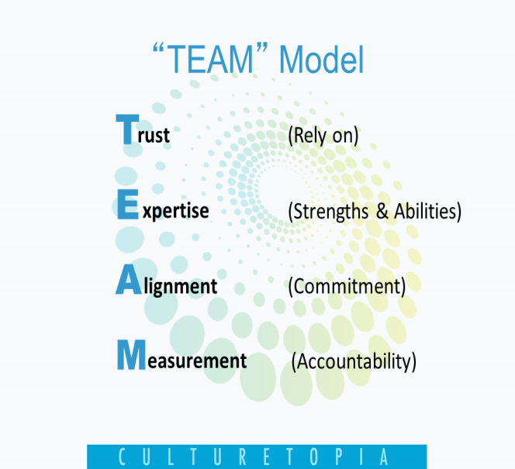

For a copy of Jason Young's complete Culturetopia presentation, click the image on the top right of this page.
Download the Culturetopia Presentation by clicking on the image below.

